

##### IOT BASED MONITORING SYSTEM FOR COAL MINING ENVIRONMENT USING LI-FI

##### A PROJECT REPORT

###### ***Submitted by***

##### KAVITHA V [REGISTER NO: 211417104115]

**KUSHMASRI V [REGISTER NO: 211417104126]**

**LAVANYA V [REGISTER NO: 211417104132]**

***in partial fulfillment for the award of the degree***

***of***

**BACHELOR OF ENGINEERING**

IN

# COMPUTER SCIENCE AND ENGINEERING

PANIMALAR ENGINEERING COLLEGE, CHENNAI-600123.

ANNA UNIVERSITY: CHENNAI 600 025

##### JUNE 2021

**BONAFIDE CERTIFICATE**

Certified that this project report “**IOT BASED MONITORING SYSTEM FOR COAL MINING ENVIRONMENT USING LI-FI**” is the bonafide work of “**KAVITHA.V (211417104115), KUSHMASRI.V (211417104126), LAVANYA.V (211417104132)”** who carried out the project work under my supervision.

**SIGNATURE SIGNATURE**

**Dr.S.MURUGAVALLI,M.E.,Ph.D., Mrs.M.S.VINMATHI,M.E**

**HEAD OF THE DEPARTMENT SUPERVISOR**

|  |  |
| --- | --- |
| DEPARTMENT OF CSE,  PANIMALAR ENGINEERING COLLEGE, NASARATHPETTAI,  POONAMALLEE,  CHENNAI-600 123. | DEPARTMENT OF CSE,  PANIMALAR ENGINEERING COLLEGE, NASARATHPETTAI,  POONAMALLEE,  CHENNAI-600 123. |

Certified that the above candidate(s) was/ were examined in the Anna University Project Viva-Voce Examination held on...........................

**INTERNAL EXAMINER EXTERNAL EXAMINER**

**ACKNOWLEDGEMENT**

We express our deep gratitude to our respected Secretary and Correspondent **Dr.P.CHINNADURAI, M.A., Ph.D.** for his kind words and enthusiastic motivation, which inspired us a lot in completing this project.

We would like to extend our heartfelt and sincere thanks to our Directors **Tmt.C.VIJAYARAJESWARI**, **Thiru.C.SAKTHIKUMAR,M.E.,** and **Tmt. SARANYASREE SAKTHIKUMAR B.E.,M.B.A.,** for providing us with the necessary facilities for completion of this project.

We also express our gratitude to our Principal **Dr.K.MANI, M.E., Ph.D.** for his timely concern and encouragement provided to us throughout the course.

We thank the HOD of CSE Department, **Dr. S.MURUGAVALLI , M.E.,Ph.D.,** for the support extended throughout the project.

We would like to thank my **Project Guide**  **Mrs.M.S.VINMATHI, M.Tech** and all the faculty members of the Department of CSE for their advice and suggestions for the successful completion of the project.

**KAVITHA.V**

**KUSHMASRI.V**

**LAVANYA.V**

**ABSTRACT**

In coal mines, there are many risk factors. In order to safe guard the people working inside the mine its environmental parameters are monitored. Coal miners are more likely affected by the various threats like gas explosion ,severe changes of the temperature and the moisture level. This project proposes a design of a wireless sensor network (WSN) with the help of microcontroller which is able to monitor the temperature, humidity, gas in an underground mine. This system utilizes low power, cost effective arduino uno, temperature sensor, humidity sensor, LDR and gas sensor for sensing the mine climate parameters and Li-Fi for remote logging of data transmission from coal mine to the control unit.Traditional coal mine monitoring systems tend to be wired network systems but with continuous enlarging of exploiting areas and extension of depth in coal mine, many lane ways become blind areas, where in there are lots of hidden dangers. Moreover, it is inconvenient to lay cables which are expensive and consume time. In order to solve the problems, we will design a coal mine safety monitoring system using Li-Fi. Light Fidelity technology is well known for its high-speed data that is sent electronically and works in visible light. The system is implemented to monitor and control various parameters in the coal mines such as light detection, leakage of gas, temperature and humidity conditions. In this system LDR sensor is utilized to detect the presence of light. Temperature and humidity values are also continuously monitored and displayed on the serial monitor and also in the thinkspeak platform.

##### TABLE OF CONTENTS

| **CHAPTER NO.** | | | **TITLE** | | **PAGE NO.** |
| --- | --- | --- | --- | --- | --- |
|  | | | **ABSTRACT** | |  |
|  | | | **LIST OF FIGURES,TABLES** | |  |
|  | | | **LIST OF SYMBOLS, ABBREVIATIONS** | |  |
| **1.** | | | **INTRODUCTION** | | 12 |
|  | | | 1.1 Overview | | 13 |
|  | | | 1.2 Problem Definition | | 14 |
| **2.** | | | **LITERATURE SURVEY** | | 15 |
| **3.** | | | **SYSTEM ANALYSIS** | | 23 |
|  | | | 3.1 Existing System | | 24 |
|  | | | 3.2 Proposed system | | 25 |
|  | | | 3.3 Requirement Analysis and Specification | | 26 |
|  | | | 3.3.1 Hardware Environment | | 27 |
|  | | | 3.3.2 Software Environment | | 27 |
| **4.** | | | **SYSTEM DESIGN** | | 28 |
|  | | | 4.1 Arduino | | 29 |
|  | | | 4.2 Ldr | | 33 |
|  | | | 4.3 LiFi | | 40 |
|  | | | 4.4 Led | | 43 |
|  | | | 4.5 Mq7 sensor | | 44 |
|  | | | 4.6 Mq6 sensor | | 58 |
|  | | | 4.7 DHT11 sensor | | 60 |
| **5.** | | | **SYSTEM ARCHITECTURE** | | 58 |
|  | | | 5.1 Architecture Overview | | 60 |
|  | | | 5.2 Module Design Specification | | 61 |
| **6.** | | | **SYSTEM IMPLEMENTATION** | | 63 |
|  | | | 6.1 Transmitter side coding | | 64 |
|  | | | 6.2 Receiver side coding | | 67 |
| **7.** | | | **SYSTEM TESTING** | | 74 |
|  | | | 7.1 Software Testing | | 75 |
|  | | | 7.2 Developing Methodologies | | 76 |
|  | | |  |
| **8.** | | | **CONCLUSION** | | 79 |
|  | | | 8.1 Conclusion  8.2 Future Enhancements | | 80  80 |
|  | | | **APPENDICES** | |  |
|  | | | A.1 Sample Screenshots | | 82 |
|  |
|  | | **REFERENCES** | | | 86 |

**LIST OF FIGURES**

|  |  |  |
| --- | --- | --- |
| **FIGURE NO** | **NAME OF THE FIGURE** | **PAGE NO.** |
| 4.1 | Arduino UNO Board | 29 |
| 4.2 | Arduino UNO Pin out diagram | 30 |
| 4.3 | Light dependent resistor | 32 |
| 4.4 | Photoresistor / light dependent resistor circuit symbols | 33 |
| 4.5 | Photoresistor structure | 35 |
| 4.6 | MQ-7 sensor, MQ7 Module | 42 |
| 4.7 | Structure and Configuration of MQ-7 | 44 |
| 4.8 | Measuring circuit of MQ-7 | 45 |
| 4.9 | Alterable situation of RL | 47 |
| 4.10 | Sensitivity Characteristics curve of the MQ-7 for several gases | 47 |
| 4.11 | Influence of Temperature and Humidity | 48 |
| 4.12 | MQ-6 Sensor and MQ-6 Module | 49 |
| 4.13 | Structure and Configuration of MQ6 Sensor | 50 |
| 4.14 | Influence of Temperature and Humidity and Sensitivity characteristics of MQ-6 for several combustible gases | 50 |
| 4.15 | DHT11Sensor | 52 |
| 4.16 | Typical application of DHT-11 | 53 |
| 5.1 | Transmitter side | 57 |
| 5.2 | Receiver side | 57 |
| 5.3 | Sensor unit | 59 |
| 5.4 | LIFI transmitter side | 60 |
| 5.5 | LIFI receiver side | 60 |
| A.1.1 | Transmitter and receiver side | 80 |
| A.1.2 | Humidity simulation output | 81 |
| A.1.3 | Temperature simulation output | 82 |
| A.1.4 | LDR simulation output | 82 |
| A.1.5 | Gas1 simulation output | 83 |
| A.1.6 | Gas2 simulation output | 83 |

**LIST OF TABLES**

|  |  |  |
| --- | --- | --- |
| **TABLE NO** | **NAME OF THE TABLE** | **PAGE NO.** |
| 4.1 | Technical specification of Arduino UNO | 29 |
| 4.2 | Key LDR/Photoresistor specifications | 38 |
| 4.3 | Example Photoresistor specifications | 39 |
| 4.4 | Specification of MQ-7 | 46 |
| 4.5 | Technical Specification of MQ-6 | 47 |
| 4.7 | Specifications of DHT-11 sensor | 54 |

**LIST OF ABBREVATION**

|  |  |  |
| --- | --- | --- |
| **S.NO** | **ABBREVATION** | **EXPANSION** |
| 1**.** | LIFI | Light fidelity |
| 2. | WSN | Wireless sensor network |
| 3. | GSM | Global System for Mobile Communication |
| 4. | CAN | Controller Area Network |
| 5. | RFID | Radio Frequency Identification Device |
| 6. | LDR | Light Dependent Resistor |

**CHAPTER 1**

**INTRODUCTION**

**1.1 OVERVIEW**

Communication is the primary key to observe any risky parameter. At present, coal mining workers are affected by accidents which is due to the complexity of my environment. So it is indispensable to monitor mine working environment condition. To deflect these damages of life and products, the proper communication system must be used. An overview of Li-Fi communication system for underground mines for passing emergency information to the worker under risk conditions is described in our project. The system includes light signal which can be used for data transmission. The recent tragic coal mine accidents have highlighted the need for reliable communications between inside and outside mines. Nowadays, most of the mines are using radio wave communication for their information exchange. While doing that, the proper data communication through radio wave is not possible at the bottom of underground mines because of irregular data propagation and limited frequency range 3 kHz-300 GHz. So, Wi-Fi technology is replaced by Light Fidelity technology, the basic idea behind this technology is visible light communication. According to this technology, it has covered wide range of frequency (430-790) THZ and fast data transmission when compared to Wi-Fi. Real-time data of underground gas, carbon monoxide, temperature, humidity and other field data are collected and transmitted to the upper computer using a high speed wireless communication technology Li-Fi.

**1.2 PROBLEM DEFINITION**

The major problem identified is that there are numerous accidents occurring in the coal mines due to improper maintenance and inadequate monitoring of the mining activities. These led to numerous loss of lives and immeasurable resources loss. There is no proper early detection of the uncertainty in the coal mines. Many miners continue to die annually, either through direct accidents in coal mines or through adverse health consequences from working under poor conditions. The safety issues of coal mines have gradually turned into a major concern for the society and nation. Since 1900, over 100,000 workers have been killed in coal mines in the U.S. (Alford, 1980) and many more have been injured and disabled. Today, safety of miners is a major challenge. Miner’s health and life is vulnerable to several critical issues, which includes not only the working environment, but also the after effect of it. Underground coal miners are exposed to a wide range of hazards including gas explosions, gas poisoning, shifting rock, falls, and machinery and mobile equipment accidents. Coal as an important source of energy in industrial production, it plays a pivotal role in the national economy.To increase the productivity and reduce the cost of mining along with consideration of the safety of workers, an innovative approach is required.

**CHAPTER 2**

**LITERATURE SURVEY**

**2. LITERATURE SURVEY**

# [1] An Efficient Implementation of Wireless Sensor Network for Performing Rescue & Safety Operation in Underground Coal Mines

**AUTHOR :** [Shilpa Lande](https://ieeexplore.ieee.org/author/37088483436); [Punam Chabukswar](https://ieeexplore.ieee.org/author/37088481879); [Vishal Bhope](https://ieeexplore.ieee.org/author/37088483799)

**YEAR :** 2020

**DESCRIPTION:**

### The structuring of the underground coal mine monitoring system based on the ZigBee wireless sensor network evacuates the traditional underground coal mine monitoring system. In this monitoring system for wireless communication, ZigBee is utilized. So, there is a significant advancement in coal mine wellbeing production which is sheltered. Aside from this, it is inadmissible to lay the links which are exorbitant and consumes additional time. To take care of this issue there is have to plan and build up an underground coal mine monitoring system using WSN. The venture is isolated into two sections. The initial segment is the underground section which is inside the coal mines and the second is the ground section which is outside of coal mine. The sensor is set inside the underground section. This sensor detects all the physical parameters, for example, ascend in temperature, unsafe gases, vibration, and increment or fall in dampness. The controller converts this information into the computerized signal. The converted information is sent towards the ground section which is outside of coal mines. For the communication between the underground section and ground section, we utilized WSN which is Zigbee.

**[2]** Monitoring System for Coal Mine Safety Based on Wireless Sensor Network

**AUTHOR :** Yingli Zhu ,Guoping You

**YEAR :** 2019

**DESCRIPTION:**

This paper designed a environment monitoring system based on sensor network. The system consists of ZigBee wireless sensor network, router, coordinator, mine network switch and monitoring computer. ZigBee wireless sensor nodes form a tree-like network topology. Real-time data of underground gas, carbon monoxide, temperature, humidity and other field data are collected and transmitted to the upper computer. The system can also extend video data acquisition function to realize real-time monitoring of mine site operation. Only by operating the monitoring interface on host computer, the managers can receive the information interaction and mine monitoring

# [3] IoT based Safety System for Coal Mines

**AUTHOR :**   [Ravi K Kodali](https://ieeexplore.ieee.org/author/38552824600); [Shubhi Sahu](https://ieeexplore.ieee.org/author/37086398287)

**YEAR :** 2018

**DESCRIPTION:**

Workers in coal mines face many environment related problems such as high temperature, humidity, release of harmful gases to name a few. These factors create a rather dangerous environment for workers to work in and thus poses a serious risk to their very lives.As a means of reducing the intensity of the problem, we have developed a model which senses these environmental parameters from different locations in the mines and sends alerts to the mines control room so that appropriate actions can be taken whenever there seems to be a dangerous situation. Here NodeMCU is used as an MQTT publisher for these parameters sensed by the different sensors. The values of these parameters from different mine locations are sent via MQTT, by being subscribed by a Raspberry Pi which acts as an MQTT broker here. When these values exceed certain threshold values, an alert by email can be sent to the mine control office so that required actions can be taken. This also generates an alarm for the workers to evacuate the place. This published data can also be stored in files for data collection and big data analytics so that more efficient systems can be developed to improve the efficiency and reduce the risk of workers potentially losing their lives.

# [4] LabVIEW based coal mine monitoring and alert system with data acquisition

**AUTHOR :** [Ashwini J. Pudke](https://ieeexplore.ieee.org/author/37086301642); [Sanket N. Bhagat](https://ieeexplore.ieee.org/author/37086040454); S. L. Nalbalwar

**YEAR :** 2017

**DESCRIPTION:**

Coal is one of the important fuels used for electricity generation, steel production, cement manufacturing and as a liquid fuel, also to produce syngas by gasification process. So as to extract this coal, which results into a great importance to the coal mining industry. A large population in the world depends on these coal mine industries for its livelihood. For this, they have to work in various dangerous conditions in the coal mine. A single, small accident can cause the death of the mine worker/workers. So it is important to have a warning system that is capable of detecting the non-safety condition in coal and generating an alarm. A research work deals with design and development of a LabVIEW and micro-controller based coal mine monitoring system using wireless technologies like ZigBee and GSM(Global System for Mobile Communication). Different types of sensors are used for sensing the physical condition parameters in coal mine like temperature, gas, humidity temperature and fire etc. These parameter signals from the sensors are continuously collected by base station situated underground the mine and sent to the ground station on the ground level. A ZigBee wireless communication system is used for the communication between underground mine base station and ground station. These signal are fed to LabVIEW which works as a signal processor and monitoring system. Being a signal processor LabVIEW continuously compares the sensed value with the predefined critical safety values and then gives the alert indication signal accordingly to the GSM system through the micro-controller for calling and sending the message to the safety division. Working as a monitoring and data acquisition system it acquires the data from all the sensors in the form of excel sheet.

**[5]** Coal Mine Safety Monitoring and Alerting System

**AUTHOR :** S. R. Deokar, J. S. Wakode

**YEAR :** 2017

**DESCRIPTION:**

Coal mine safety monitoring system based on wireless sensor network can timely and accurately reflect dynamic situation of staff in the underground regions to ground computer system and mobile unit. The air pollution from coal mines is mainly due to emissions of particulate matter and gases include sulphur dioxide (SO2), nitrogen dioxide (NO2), carbon monoxide (CO) etc. To monitor the concentration level of harmful gases, semiconductor gas sensors are used. Due to any reason miner’s falls down and lose consciousness also proper treatment is not provided them at that time, so number of miners are died. To overcome this problem the system provide emergency alert to the supervisor if person fall down by any reason. Some workers are not aware for safety and they are not wear helmet. A Limit switch was then used to successfully determine whether a miner has removed his helmet or not. This system also provides an early warning, which will be helpful to all miners present inside the mine to save their life before any casualty occurs. The system uses Zigbee technology and GSM for transmission of data. There is alert switch at receiver and transmitter side for emergency purpose.

# [6] Mine safety system using wireless sensor networks

**AUTHOR :** [Valdo Henriques](https://ieeexplore.ieee.org/author/37085785273); [Reza Malekian](https://ieeexplore.ieee.org/author/37660874600); [Dijana Capeska Bogatinoska](https://ieeexplore.ieee.org/author/37085835381)

**YEAR :** 2017

**DESCRIPTION:**

The system consists of Measurement nodes and a Data collections station. The measurement node consists of different sensors which detects the values of temperature, humidity, gas concentration, air-flow and noise levels. These measured values are transferred to the data collection center using a wireless network. Each of these sensors has their own respective signal processing circuits. The input from the sensor is sampled by the micro controller, which forms the central processing Unit (CPU) of the measurement module. The microcontroller also has a timer which determines the delay between two sensor sample readings. A wireless communication module is also integrated into the microcontroller for transmitting data to the data collection station.

# [7] Design of Coal Mine Intelligent Monitoring System based on ZigBee Wireless Sensor Network

**AUTHOR :** Dan Gao, Weiwei Li, Kun Dai

**YEAR :** 2016

**DESCRIPTION:**

This paper introduces the overall architecture of coal mine intelligent monitoring system. Focusing on two key issues of intelligent control and ZigBee wireless sensor networks were studied. Coal mine intelligent monitoring system can be used to monitor the concentration of carbon monoxide, carbon dioxide concentration, oxygen concentration, wind speed, air pressure, smoke, temperature and etc.. Sensor data are transmitted by the ZigBee wireless sensor network to the monitor host machine which using intelligent control scheme to make control decisions. The system can be used to monitor to coal mine. The operation of system has the very high actual effect.

# [8] The study on coal mine using the Bluetooth wireless transmission

**AUTHOR :** [Yongping Wu](https://ieeexplore.ieee.org/author/37086720548); [Guo Feng](https://ieeexplore.ieee.org/author/37086718412); [Zhang Meng](https://ieeexplore.ieee.org/author/37086717555)

**YEAR :** 2014

**DESCRIPTION:**

The safety of coal mine is an important link in coal mine production,gas disaster is the most harmful for the safety of coal mine production. During the process of mine development, it is very important to measure the gas concentration in mines. For the present of situation of gas concentration monitoring system, this paper proposes a Bluetooth-based coal mine gas concentration monitoring system design, describes the ideas and specific methods software and hardware design. As a standard of unified global short-range wireless communication, Bluetooth technology is to establish a common low-power, low-cost wireless air interface and controlling software opening system. This paper describes the development background, technical features and the structure of the protocol stack of Bluetooth technology, and proposed the solutions of the Bluetooth host controller interface (HCI) wireless communication for the complexity of its development. At the same time, the system uses CAN bus technology maturely, has realized the combination of wired and wireless data transmission system.

# [9] Implementation of smart safety helmet for coal mine workers

**AUTHOR :** [Pranjal Hazarika](https://ieeexplore.ieee.org/author/37086042574)

**YEAR :** 2016

**DESCRIPTION:**

This paper presents implementation of safety helmet for coal mine workers. This helmet is equipped with methane and carbon monoxide gas sensor. It is on the safety helmet of the coal mine workers This sensor sense the gas and the data is transmitted to the control room wirelessly, through a wireless module called X-Bee connected with the helmet. When the methane or carbon-monoxide gas concentration is beyond the critical level, controller in the control room triggers an alarm and keeps the plant and the workers safe by preventing an upcoming accident. A smart safety helmet having sensor array to sense data and a wireless modem to transmit it.

# [10] Intelligent coal mine monitoring system based on the Internet of Things

**AUTHOR :** [Shushan Hu](https://ieeexplore.ieee.org/author/37086781979); [Cunchen Tang](https://ieeexplore.ieee.org/author/37678414900); [Riji Yu](https://ieeexplore.ieee.org/author/37086783325); [Feng Liu](https://ieeexplore.ieee.org/author/37086779375); [Xiaojun Wang](https://ieeexplore.ieee.org/author/37311501100)

**YEAR :** 2013

**DESCRIPTION:**

Due to many people died in mine accident, the mine safety play a key role in mine produce process. By virtual of recent advancements in the Internet of Things, this paper proposes an intelligent monitoring system for coal mines, which aims at monitoring the coal mine produce process. The proposed sense network architecture is completed based on Controller Area Network (CAN) bus and ZigBee technology. The sense nodes work cycle, powered by batteries, is extended by specific work model. Position of miners can be obtained through inquiry routing tables of network nodes. Manage system is designed to provide services for mine managers. The proposed system can monitor the process of mining intelligently and warn miners and managers immediately when dangerous issues emerge, such as gas leaking and water leaking.

**CHAPTER 3**

**SYSTEM ANALYSIS**

**3. SYSTEM ANALYSIS**

**3.1 EXISTING SYSTEM**

Traditional coal mine safety monitoring system adopts wired network to transmit. In the mining process, the wired communication system is not so efficient. The most famous system for underground mines communication is Radio Frequency Identification Device (RFID) system. It is comprised of radio frequency identifier tags, RFID readers, routers and a host station. RFID tags are very small chips capable of storing a specified amount of data in its circuitry. RFID tags area unit of 2 sorts, active and passive. In underground mine application, active tags should be used having the signal range of 100 meters, whereas for passive tags the allowed range is 6-8 meters [9]. In addition to above, there are many wireless systems such as; Wi-Fi (IEEE 802.11), Bluetooth (IEEE 802.15) and Wi-Max used in underground mines application. Zigebee based wireless data transmission is used widely in coal mine monitoring system. In this system,the data of the concentration level of harmful gases and hazardous event of coal mines are transmitted to the base station using Zigbee.Ultra Wide Band system is another radio system for short-range communication with very low power and very high data rate.

**DRAWBACKS OF EXISTING SYSTEM**

* The wired connections will fail in natural calamities such as landslides, earthquake etc.,
* Re-installation cost of the wired networks is also a disadvantage for these connections.
* The wired connection requires a lot of maintenance cost also.
* Zigbee ,Wi-Fi based data transmission can be used only for short range communication.

**3.2 PROPOSED SYSTEM**

The main objective of the proposed method is to improve the effective data transmission from the base station to receiving station in the underground mines. At present, the Wi-Fi technology has been used for information exchange along with large delay which affects the data transmitting speed and loss of the data. This problem can be overcome by proposed method and give effective communication between sender and receiver. Here, working procedure is same as that of Wi-Fi but instead of radio wave the light wave is used from the lighting arrangement in the underground mine and power consumption of these light also very low. The lightning system consists of the Li-Fi circuit driver to sense the signal from the base station through the light the photo detector in the device capture the signal and passes the data to the monitoring section of the underground mines

In this proposed system the coal mine safety systems are fixed with gas sensor modules, the light dependent resistor(LDR sensor), temperature sensor ,humidity sensor, fire sensor, buzzer and led. We integrate all the sensors to the Arduino uno. In this system we mainly have monitoring and controlling systems monitoring system where monitor all the data from different sensors. Gas sensor detects the gas in the coal mine environment, if the gas level exceeds the normal level then the buzzer gets high so that the mine workers gets notified. The temperature and humidity values are also he monitored inside the coalmine. LDR sensor is used to measure the intensity of the light by varying its resistance value.

**ADVANTAGES OF PROPOSED SYSTEM:**

* The transmission separation of Li-Fi is faster than other wireless data transmission systems.
* Driven devours less power and gives more effectiveness. It gives more channels to Transmit and thus there will be more data transfer capacity.
* These waves are innocuous since it is light.
* It tends to be utilized anyplace with no issues.
* The light waves are quick and can’t be seen by the human eyes. It is hard to hack the data or information in the Li-Fi innovation. The information is particularly verified.

**3.3 REQUIREMENT ANALYSIS AND SPECIFICATION**

* These are requirements for doing the project. Without using these tools and software’s we can’t do the project. So we have two requirements to do the project. They are

1. Hardware Requirements

2. Software Requirements.

**3.3.1 HARDWARE REQUIREMENTS**

The hardware requirements may serve as the basis for a contract for the implementation of the system and should therefore be a complete and consistent specification of the whole system. They are used by software engineers as the starting point for the system design. It shows what the system does and not how it should be implemented.

PROCESSOR : PENTIUM IV 2.6 GHz, Intel Core 2 Duo.

RAM : 4GB DD RAM

MONITOR : 15” COLOR

HARD DISK : 40 GB

**3.3.2 SOFTWARE REQUIREMENTS**

The software requirements document is the specification of the system. It should include both a definition and a specification of requirements. It is a set of what the system should do rather than how it should do it. The software requirements provide a basis for creating the software requirements specification. It is useful in estimating cost, planning team activities, performing tasks and tracking the teams and tracking the team’s progress throughout the development activity.

Operating System : Windows 07

Coding Language : C/C++

Coding Platform : Arduino IDE

**CHAPTER 4**

**SYSTEM DESIGN**

**4.SYSTEM DESIGN:**

This chapter consists of the design of the system. This chapter mainly contains the details of required hardware and software. The appropriate working environment is setup with all required components to develop the system. After developing the system, it tested in the particular environment. This chapter explains the step-by-step development of hardware system followed by software development and its implementation

**SYSTEM HARDWARE DESIGN**

This monitoring system contains several components like boards (Arduino board, Li-Fi Transmitter/Receiver), LDR (Light Dependent Resistor), different sensors and other small electronic components. This chapter gives a detailed review of each of this part along with its working principle.

**4.1 ARDUINO**

Arduino is an open source hardware and software based on microcontroller which is very easy to use. Arduino is an inexpensive control board that's easy to program and can hook up to a wide variety of hardware. It is intended for anyone making project. Arduino senses the environment by receiving input from many sensors and affects its surroundings. In the market, various types of Arduino board are available such as Arduino UNO, Arduino Leonardo, Arduino due, Arduino Yun, Arduino Mega etc. Arduino UNO has been used for this system.

### Arduino UNO

The Arduino board is a specially designed circuit board for programming and prototyping with Atmel microcontrollers. The microcontroller on the board is programmed using the Arduino Programming Language (based on Wiring) and the Arduino development environment (based on Processing). It is relatively cheap and plug straight to computer’s USB port or power it with an AC-to-DC adapter or battery to get started.

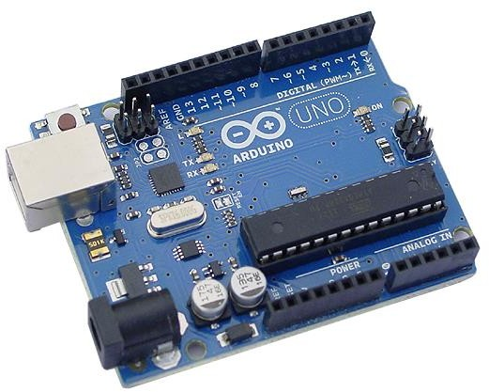

**Figure 4-1** Arduino UNO Board

**Table 4-1** Technical specification of Arduino UNO

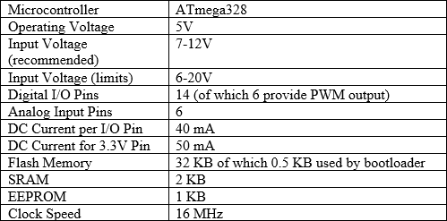

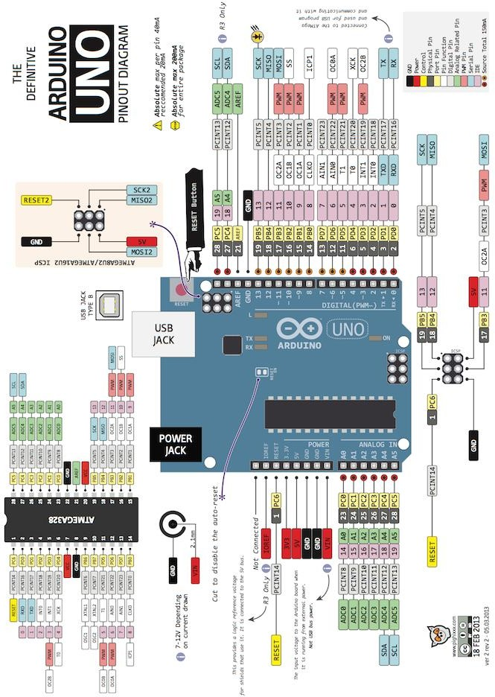

**Figure 4-2** Arduino UNO Pin out diagram

Arduino UNO has 14 digital input/output pins (of which 6 can be used as PWM outputs), 6 analog inputs, a 16 MHz crystal oscillator, a USB connection, a power jack, an ICSP header, and a reset button. The Atmega328 has 32 KB of flash memory for storing code (of which 0.5 KB is used for the bootloader). Each of the 14 digital pins can be used as input or output and these operate at 5V.

The functions of these digital pins are predefined like 0 and 1 pins wok for receiving and transmitting data, 2 and 3 pins act as external interrupts which can be configured to trigger an interrupt on a low value and a rising or falling edge, 3, 5, 6, 9, 10, and 11 pins provide 8-bit PWM output, 10, 11, 12 and 13 pins support SPI communication.

Each of 6 analog pins can be used as analog input, which provides 10 bits of resolution (1024 different value). These pins measure from ground to 5V.

Arduino UNO can communicate with a computer or other Arduino or other microcontrollers. It communicates via serial communication (UART TTL). This serial communication appears as a virtual com port to software on the computer.

**4.2 LDR:**

Light dependent resistors, LDRs or photoresistors are often used in electronic circuit designs where it is necessary to detect the presence or the level of light.These electronic components can be described by a variety of names from light dependent resistor, LDR, photoresistor, or even photo cell, photocell or photoconductor.Although other electronic components such as photodiodes or photo-transistor can also be used, LDRs or photo-resistors are a particularly convenient to use in many electronic circuit designs. They provide large change in resistance for changes in light level.In view of their low cost, ease of manufacture, and their ease of use, LDRs have been used in a variety of different applications. At one time LDRs were used in photographic light meters, and even now they are still used in a variety of applications where it is necessary to detect light levels.Light dependent resistors are widely available:- they are normally stocked by electronic component distributors, and in view of the way the electronics industry supply chain operates these days, this is the normal way to obtain them. Electronic component distributors large and small will typically have a good selection.

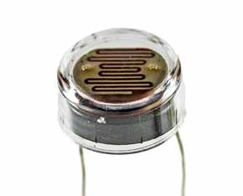

**Fig 4.3** Light dependent resistor

A photoresistor or light dependent resistor is an electronic component that is sensitive to light. When light falls upon it, then the resistance changes. Values of the resistance of the LDR may change over many orders of magnitude the value of the resistance falling as the level of light increases.It is not uncommon for the values of resistance of an LDR or photoresistor to be several megohms in darkness and then to fall to a few hundred ohms in bright light. With such a wide variation in resistance, LDRs are easy to use and there are many LDR circuits available. The sensitivity of light dependent resistors or photoresistors also varies with the wavelength of the incident light.LDRs are made from semiconductor materials to enable them to have their light sensitive properties. Many materials can be used, but one popular material for these photoresistors is cadmium sulphide, CdS, although the use of these cells is now restricted in Europe because of environmental issues with the use of cadmium.Similarly cadmium CdSe is also restricted. Other materials that can be used include lead sulphide, PbS and indium antimonide, InSb.Although a semiconductor material is used for these photoresistors, they are purely passive devices because they do not possess a PN junction, and this separates them from other photodetectors like photodiodes and phototransistors.

## **LDR SYMBOL**

The LDR symbol used in electronic circuits is based around the resistor circuit symbol, but shows the light, in the form of arrows shining on it. In this way it follows the same convention used for photodiode and phototransistor circuit symbols where arrows are used to show the light falling on these components.

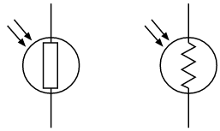

**Fig 4.4** Photoresistor / light dependent resistor circuit symbols

The light dependent resistor / photoresistor circuit symbols are shown for both the newer style resistor symbol, i.e. a rectangular box and the older zig-zag line resistor circuit symbols.

**WORKING OF LDR**

It is relatively easy to understand the basics of how an LDR works without delving into complicated explanations. It is first necessary to understand that an electrical current consists of the movement of electrons within a material.Good conductors have a large number of free electrons that can drift in a given direction under the action of a potential difference. Insulators with a high resistance have very few free electrons, and therefore it is hard to make the them move and hence a current to flow.An LDR or photoresistor is made any semiconductor material with a high resistance. It has a high resistance because there are very few electrons that are free and able to move - the vast majority of the electrons are locked into the crystal lattice and unable to move. Therefore in this state there is a high LDR resistance.As light falls on the semiconductor, the light photons are absorbed by the semiconductor lattice and some of their energy is transferred to the electrons. This gives some of them sufficient energy to break free from the crystal lattice so that they can then conduct electricity. This results in a lowering of the resistance of the semiconductor and hence the overall LDR resistance.

The process is progressive, and as more light shines on the LDR semiconductor, so more electrons are released to conduct electricity and the resistance falls further.

**LDR STRUCTURE**

Structurally the photoresistor is a light sensitive resistor that has a horizontal body that is exposed to light.The basic format for a photoresistor is that shown below:

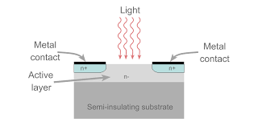

**Fig 4.5** Photoresistor structure

The active semiconductor region is normally deposited onto a semi-insulating substrate and the active region is normally lightly doped.In many discrete photoresistor devices, an interdigital pattern is used to increase the area of the photoresistor that is exposed to light. The pattern is cut in the metallisation on the surface of the active area and this lets the light through. The two metallise areas act as the two contacts for the resistor. This area has to be made relatively large because the resistance of the contact to the active area needs to be minimised.Photoresistor structure showing interdigital pattern to maximise exposed area.This type of structure is widely used for many small photoresistors or light dependent resistors that are seen. The interdigital pattern is quite recognisable.The materials used for photoresists are semiconductors and include materials such as CdSe, CdS, CdTe, InSb, InP, PbS, PbSe, Ge, Is, GaAs. Each material gives different properties in terms of the wavelength of sensitivity, etc.

## **TYPES OF LDR**

Light dependent resistors, LDRs or photoresistors fall into one of two types or categories:

* ***Intrinsic photoresistors:***   Intrinsic photoresistors use un-doped semiconductor materials including silicon or germanium. Photons fall on the LDR excite electrons moving them from the valence band to the conduction band. As a result, these electrons are free to conduct electricity. The more light that falls on the device, the more electrons are liberated and the greater the level of conductivity, and this results in a lower level of resistance.
* ***Extrinsic photoresistors:***   Extrinsic photoresistors are manufactured from semiconductor of materials doped with impurities. These impurities or dopants create a new energy band above the existing valence band. As a result, electrons need less energy to transfer to the conduction band because of the smaller energy gap.

Regardless of the type of light dependent resistor or photoresistor, both types exhibit an increase in conductivity or fall in resistance with increasing levels of incident light.

## **LDR FREQUENCY DEPENDENCY**

The sensitivity of photoresistors is shown to vary with the wavelength of the light that is impacting the sensitive area of the device. The effect is very marked and it is found that if the wavelength is outside a given range then there is no noticeable effect.Devices made from different materials respond differently to light of different wavelengths, and this means that the different electronics components can be used for different applications.It is also found that extrinsic photoresists tend to be more sensitive to longer wavelength light and can be used for infrared. However when working with infrared, care must be taken to avoid heat build-up caused but he elating effect of the radiation.One important aspect associated with photoresistors or light dependent resistors is that of the latency, or the time taken for the electronic component to respond to any changes. This aspect can be particularly important for a circuit design.It takes a noticeable amount of time from any changes in light level before the LDR / photoresistor attains its final value for the new level of light and for this reason the LDR / photo resistor is not a good choice where there are reasonably rapid changing values of light. However when the light changes take place over a period of time they are more than adequate.The rate at which the resistance changes is called the resistance recovery rate. The LDR / photoresistor normally responds within a few tens of milliseconds when light is applied after total darkness, but when light is removed it can take up to a second or so for the resistance to reach its final level.It is for this reason that one of the specifications normally quoted in the electronic component datasheets for photo-resistors is the dark resistance after a given time, typically in seconds. Often two values are quoted, one for one second and another for five seconds. These given an indication of the latency of the resistor.

**LDR APPLICATIONS**

* Photoresistors are found in many different applications and can be seen in many different electronic circuit designs. They have a very simple structure and they are low cost and rugged devices. They are widely used in many different items of electronic equipment and circuit designs including photographic light meters, fire or smoke alarms as well as burglar alarms, and they also find uses as lighting controls for street lamps.
* Extrinsic photoresistors are provide sensitivity for longer wavelengths and as a result they are popular in various electronic circuit designs as info-red photodetectors. Photoresistors can also be used to detect nuclear radiation.

**LDR SPECIFICATIONS**

There are several specifications that are important for light dependent resistors, LDRs / photoresistors when considering their use in any electronic circuit design.

|  |  |
| --- | --- |
| **TABLE 4.2 KEY LDR / PHOTORESISTOR SPECIFICATIONS** | |
| **PARAMETER** | **DETAILS** |
| Max power dissipation | This is the maximum power the device is able to dissipate within a given temperature range. Derating may be applicable above a certain temperature. |
| Maximum operating voltage | Particularly as the device is semiconductor based, the maximum operating voltage must be observed. This is typically specified at 0 lux, i.e. darkness. |
| Peak wavelength | This photoresistor specification details the wavelength of maximum sensitivity. Curves may be provided for the overall response in some instances. The wavelength is specified in nm |
| Resistance when illuminated | The resistance under illumination is a key specification is a key parameter for any photoresistor. Often a minimum and maximum resistance is given under certain light conditions, often 10 lux. A minimum and maximum vale may be given because of the spreads that are likely to be encountered. A 'fully on' condition may also be given under extreme lighting, e.g. 100lux. |
| Dark resistance | Dark resistance values will be given for the photoresistor. These may be specified after a given time because it takes a while for the resistance to fall as the charge carrier recombine - photoresistors are noted for their slow response times. |

|  |  |
| --- | --- |
| **TABLE 4.3 EXAMPLE PHOTORESISTOR SPECIFICATIONS** | |
| **PARAMETER** | **EXAMPLE FIGURES** |
| Max power dissipation | 200Mw |
| Max voltage @ 0 lux | 200V |
| Peak wavelength | 600nm |
| Min. resistance @ 10lux | 1.8Kω |
| Max. resistance @ 10lux | 4.5kΩ |
| Typ. resistance @ 100lux | 0.7kΩ |
| Dark resistance after 1 sec | 0.03MΩ |
| Dark resistance after 5 sec | 0.25MΩ |

LDRs are very useful electronic components that can be used for a variety of light sensing applications and their associated electronic circuit designs. As the LDR resistance varies over such a wide range, they are particularly useful, and there are many LDR circuit designs available beyond any shown here. In order to utilise these electronic components, it is necessary to know something of how an LDR works, which has been explained above.

**4.3 LIFI**

Li-Fi (Light Fidelity) is a quick and modest optical variant of correspondence. The primary parts of this correspondence framework are a high-force white LED which goes about as a correspondence source and silicon Photodiode which demonstrates a decent reaction to unmistakable wavelength district filling in as the getting component. A critical factor while structuring Li-Fi is Line of Sight (LOS). The LED can be turned on and off to create computerized series of 0s. Information is coded in the light which changes into new information by fluctuating the flashing rate of the LED.

**LIFI TECHNOLOGY**

**LiFi (light fidelity) is a bidirectional wireless system that transmits data via LED or infrared light.** It was first unveiled in 2011 and, unlike wifi, which uses radio frequency, LiFi technology only needs a light source with a chip to transmit an internet signal through light waves.This is an extraordinary advance over today's wireless networks. **LiFi multiplies the speed and bandwidth of wifi, 3G and 4G.** The latter have a limited capacity and become saturated when the number of users surfing increases, causing them to crash, reducing speeds and even interrupting the connection.With LiFi, however, its band frequency of 200,000 GHz, versus the maximum 5 GHz of the wifi, is 100 times faster and can transmit much more information per second. A 2017 study by the University of Eindhoven obtained a **download rate of 42.8 Gbit/s with infrared light with a radius of 2.5 metres,** when the best wifi would barely reach 300 Mbit/s.

**DATA TRANSMISSION THROUGH LIFI**

Every LED lamp should be powered through an LED driver, this LED driver will get information from the Internet server and the data will be encoded in the driver. Based on this encoded data the LED lamp will flicker at a very high speed that cannot be noticed by the human eyes. But the Photo Detector on the other end will be able to read all the flickering and this data will be decoded after Amplification and Processing. The data transmission of LIFI will be very fast than RF. Here we are using Solar panel at the receiving end to sense light.

**WORKING**

Light fidelity technology is known for the high data speed and the data are transmitted electromagnetically and runs on visible light. It uses the common light emitting diodes which is at the sender side and photo detector is placed at the receiver end, the The analog signals which are detected by the various sensors are given to the LI-FI transmitter, here the analog signals are converted into the digital signals and the these digital data are received by the photodetector or the LI_FI receiver , the received data can be converted into any forms such as video and audio application or the web enabled services and the main advantages of LI-FI are high speed, data density, security, device to device connectivity.

**LIFI VS. WIFI:**

* LiFi technology is faster, cheaper and even more secure than wifi. Its main advantages include:
* **Faster:** the current speed of wifi oscillates between 11 and 300 Mbit/s, while that of LiFi is also highly variable according to the last studies carried out. The most widely accepted speed is 10 Gbit/s, but it has been proven that it could reach 224 Gbit/s and that a 1.5 Gbit film could be downloaded in thousandths of a second.
* **Cheaper and more sustainable:** it is up to 10 times cheaper than wifi, requires fewer components and uses less energy. All you have to do is turn on a light!
* **More accessible:** any light fitting can easily be converted into an internet connection point, as only a simple LiFi emitter needs to be fitted.
* **More secure:** light does not pass through walls like radio waves do, and this prevents intruders from intercepting LiFi communications through a wireless network.
* **More bandwidth:** the light spectrum is 10,000 times wider than the radio spectrum, which increases the volume of data it can carry and transmit per second.
* **More reliable:** LiFi transmits its signal without interruptions, making communication more stable than with wifi.
* **No interference:** electronic light does not interfere with radio communications, interact with other systems or compromise transmissions from aircraft, ships, etc.
* **Wireless and invisible:** LiFi takes advantage of lights and dispenses with the router, so it works without the need for cables. In addition, it can operate with infrared light, which is invisible to the human eye, or with visible LED light at very low intensity so as to avoid disturbance.
* **No saturation:** internet connection via light could prevent the collapse of the radio spectrum which, according to LiFi's inventor Harald Haas, could take place by 2025.
* With the emergence and development of LiFi technology, many foreshadow the obsolescence of wifi and other wireless networks. We will have to wait a few more years to see if streetlights, in addition to illuminating our streets, will connect us to the internet at the speed of light.

**4.4 LED:**

LEDs emit light when an electric current passes through them. Connecting and soldering LEDs must be connected the correct way round, the diagram may be labelled a or + for anode and k or - for cathode (yes, it really is k, not c, for cathode!). The cathode is the short lead and there may be a slight flat on the body of round LEDs. If you can see inside the LED the cathode is the larger electrode (but this is not an official identification method). LEDs can be damaged by heat when soldering, but the risk is small unless you are very slow. No special precautions are needed for soldering most LEDs. Fig 9: Different forms of LED Testing an LED: Never connect an LED directly to a battery or power supply! It will be destroyed almost instantly because too much current will pass through and burn it out. LEDs must have a resistor in series to limit the current to a safe value, for quick testing purposes a 1k resistor is suitable for most LEDs if your supply voltage is 12V or less. Remember to connect the LED the correct way round! LEDs are available in red, orange, amber, yellow, green, blue and white. Blue and white LEDs are much more expensive than the other colours.

### 4.5 MQ7 SENSOR:

Various types of sensors are available in the market in which semiconductor sensors are considered to have fast response. MQ7 semiconductor sensor is mainly used for detecting carbon monoxide (CO).

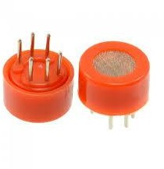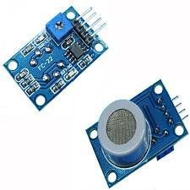 **Figure 4-6** MQ-7 sensor, MQ7 Module

MQ-7 gas sensor composed of micro Al2O3 ceramic tube and Tin Dioxide (SnO2). Electrode and heater are fixed into a crust. The heater provides required work conditions for the work of sensitive components.

The conductivity of sensor is higher along with the gas concentration rising. When the sensor, heated by 5V it reaches at high temperature, it cleans the other gases adsorbed under low temperature. The MQ-7 have 6 pins in which 4 of them are used to fetch signals and other 2 are used for providing heating current.

### Parts Materials

1. Gas sensing layer SnO2
2. Resin base Bakelite
3. Electrode line Pt
4. Tube Pin Copper plating Ni
5. Tubular ceramic Al2O3
6. Electrode Au
7. Clamp ring Copper plating Ni
8. Heater coil Ni-Cr alloy
9. Anti-explosion network Stainless steel gauze

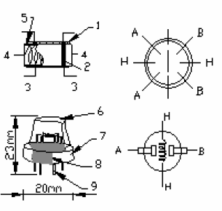 **Figure 4-7** Structure and Configuration of MQ-7

MQ-7 sensor consist of 2 parts. One is heating circuit and the other one is the signal output circuit. In which heating circuit is used for time control and signal output circuit is accurately respond changes of surface resistance of the sensor.

### Working Principle and Test Circuit for the MQ-7 Sensor

The surface resistance of the sensor is measured through the voltage signal output of the load resistance.



The sensor needs to be put 2 voltages for detecting CO in which, the heater voltage used to supply certified working temperature of the sensor and the test voltage used to detect voltage (VRL) on load resistance (RL) whom is in series with the sensor. In order to make the sensor with better performance, suitable RL value is needed:



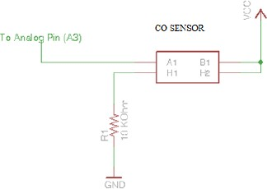

**Figure 4-8** Measuring circuit of MQ-7

**Table 4-4** Specification of MQ-7

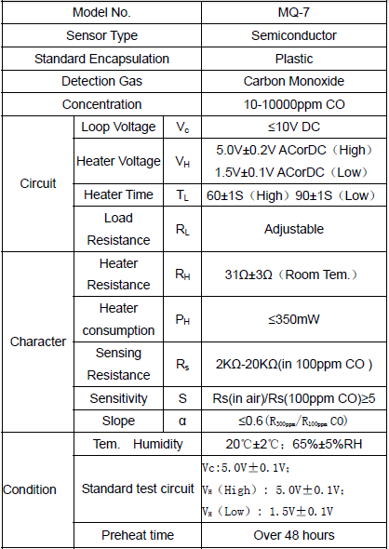

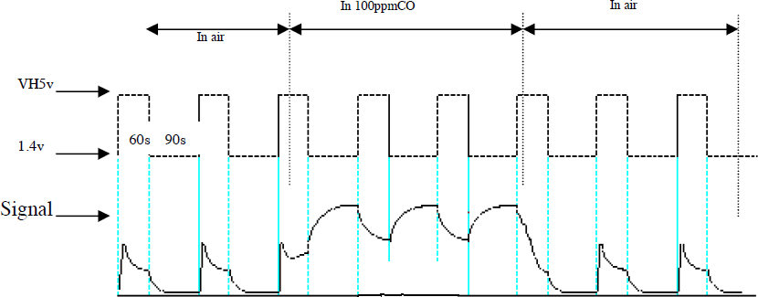

**Figure 4-9** Alterable situation of RL

Figure 4-9 shows the output signal of the sensor when it is moved from clean air to CO laden air. The readings are taken at one or two complete heating cycle.

**Figure 4-10** Sensitivity Characteristics curve of the MQ-7 for several gases

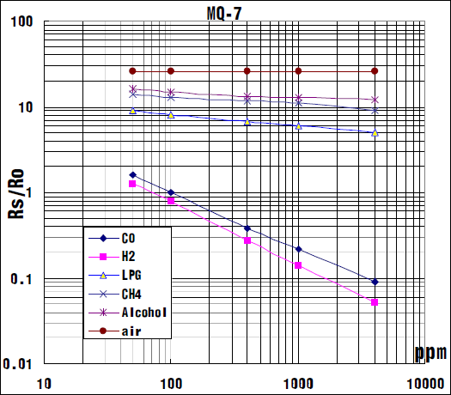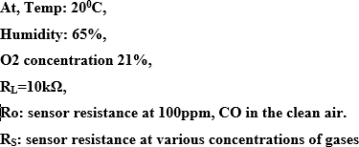

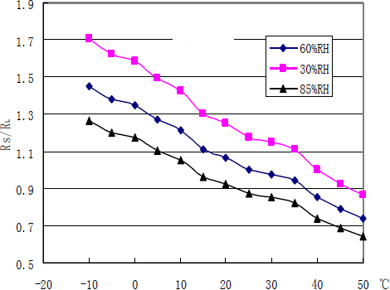

**Figure 4-11** Influence of Temperature and Humidity

### Features

* + Simple drive circuit
  + Sensitivity to flammable gas in wide range
  + Long life and low cost
  + High sensitivity to Natural gas

### Application

* Domestic gas leakage detector
* Industrial CO detector

### 4.6 MQ-6 SENSOR

MQ-6 gas sensor composed of ceramic tube and Tin Dioxide. Electrode and heater are fixed into a layer. The heater provides required work conditions for the work of sensitive components.

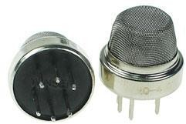 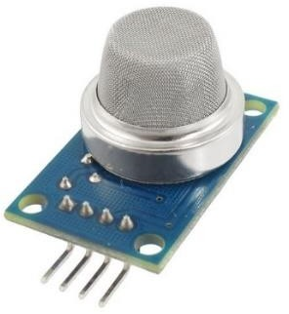

**Figure 4-12** MQ-6 Sensor and MQ-6 Module

When the target combustible gas present, the conductivity of sensor is higher along with the gas concentration rising. The MQ-6 sensor has 6 pins in which 4 of them are used to fetch signals and other 2 are used for providing heating current.

### Parts Materials

1. Gas sensing layer SnO2
2. Clamp ring Copper plating Ni
3. Heater coil Ni-Cr alloy
4. Electrode Au
5. Tubular ceramic Al2O3
6. Anti-explosion Network Stainless steel gauze
7. Electrode line Pt

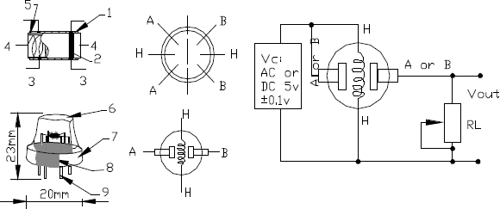

**Figure 4-13** Structure and Configuration of MQ-6 Sensor

**Figure 4-14** Influence of Temperature and Humidity and Sensitivity characteristics of MQ-6 for several combustible gases

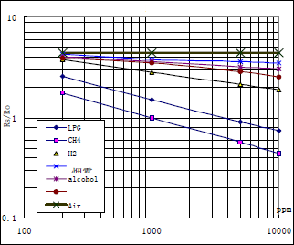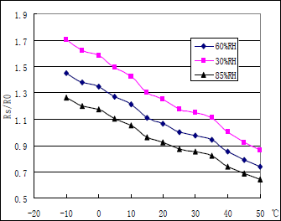

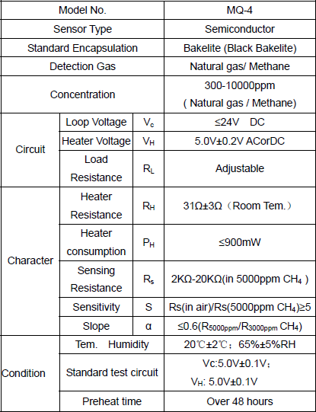 **TABLE 4.5** Technical specifications of MQ-6

**FEATURES**

* High sensitivity to CH4.
* Small sensitivity to alcohol and smoke.
* Fast response
* Stable and long life

### APPLICATIONS:

* Domestic gas leakage detector
* Industrial Combustible gas detector

### 4.7 DHT-11 SENSOR

This DHT11 Sensor measures the temperature and humidity. The sensor has greater reliability and very good stability. A resistive-type humidity measuring component with negative temperature coefficient is used. It connects to a microcontroller and shows excellent quality, anti-interference and fast response ability.

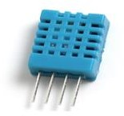 **Figure 4-15** DHT11Sensor

### Application of DHT-11

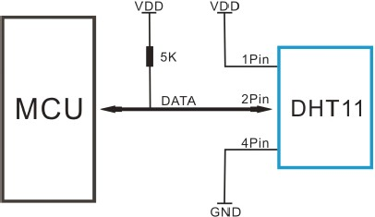 **Figure 4-16** Typical application of DHT-11

**TABLE 4-6** Specifications of DHT-11 sensor

|  |  |  |  |  |
| --- | --- | --- | --- | --- |
| **Parameters** | **Conditions** | **Minimum** | **Typical** | **Maximum** |
| **Humidity** | | | | |
|  | | | | |
| **Accuracy** | 25℃ |  | ±4%RH |  |
| 0-50℃ |  |  | ±5%RH |
| **Measurement Range** | 0℃ | 30%RH |  | 90%RH |
| 25℃ | 20%RH |  | 90%RH |
| 50℃ | 20%RH |  | 80%RH |
| **Response Time (Seconds)** | 1/e (63%)  25℃， | 6 S | 10 S | 15 S |
| **Long-term Stability** | Typical |  | ±1%RH/year |  |
|  | | | | |
| **Temperature** |  |  |  | |
| **Accuracy** |  | ±1℃ |  | ±2℃ |
| **Measurement Range** |  | 0℃ |  | 50℃ |
| **Response Time**  **(Seconds)** | 1/e (63%) | 6 S |  | 30 S |

**CHAPTER 5**

**SYSTEM ARCHITECTURE**

**5.1 ARCHITECTURE OVERVIEW**

**TRANSMITTER SIDE:**

ARDUINO UNO

Temperature sensor

LI-FI TRANSMITTER MODULE

Humidity sensor

Gas sensor

LED

TRANSMITTER CIRCUIT

LDR

**Figure 5-1**  Transmitter side

**RECEIVER SIDE:**

IOT CLOUD PLATFORM

ARDUINO UNO

LIFI RECEIVER

AMPLIFIER

DETECTOR

**Figure 5-2** Receiver side

**EXPLANATION:**

This architecture will be fixed with some sensors that are temperature sensor, gas sensor , humidity sensor and LDR sensor and all these sensors are interfaced with microcontroller. Arduino uno is connected to transmitter Li-Fi module in order to transmit the information if any parameter variation in the mining area to receiver Li-Fi module located in Receiver PC. The concentration node consists of Receiver PC which is wirelessly connected to the receiver Li-Fi module in order to collect the information stored in the cloud through IoT and provide safety measures for the mine workers when hazardous conditions occurs in the mining area. In this system LDR sensor is utilized to detect the presence of light. Temperature,humidity,gas and ldr values are also continuously monitored and displayed on the serial monitor and also in the thinkspeak platform.

**5.2 MODULE DESIGN SPECIFICATION**

* + - Sensor unit
    - Li-Fi Transmitter side
    - Li-Fi Receiver Side
    - Monitoring using IOT cloud platform

**SENSOR UNIT:**

We integrate all the sensors to the Arduino uno. In this system we mainly have monitoring and controlling systems monitoring system where monitor all the data from different sensors. Gas sensor detects the gas in the coal mine environment. The temperature and humidity values are also he monitored inside the coalmine

LDR sensor used to detect the light intensity in the working environment based upon that ,the brightness of the light is monitored using the IOT cloud platform Thinkspeak.

ARDUINO UNO

HUMIDITY SENSOR

GAS SENSOR

LDR

TEMPERATURE SENSOR

**Figure 5.1** Sensor unit

**LIFI TRANSMITTER SIDE:**

Light fidelity technology is known for the high data speed and the data are transmitted electromagnetically and runs on visible light.

It uses the common light emitting diodes which is at the sender side and photo detector is placed at the receiver end, the The analog signals which are detected by the various sensors are given to the LI-FI transmitter

ARDUINO

LI FI TRANSMITTER

SENSORS

**Figure 5.2** LIFI Transmitter side

**LIFI RECEIVER SIDE:**

In this module , the analog signals are converted into the digital signals and the these digital data are received by the the LIFI receiver .

The received data can be converted into any forms such as video and audio application or the web enabled services and the main advantages of LI-FI are high speed, data density, security, device to device connectivity.

IOT CLOUD

ARDUINO

LIFI TRANSMITTER

**Figure 5.3** LIFI Receiver side

**MONITORING USING IOT CLOUD PLATFORM:**

ThingSpeak is an IoT analytics platform service that allows you to aggregate, visualize and analyze live data streams in the cloud. ThingSpeak provides instant visualizations of data posted by your devices to ThingSpeak. With the ability to execute MATLAB code in ThingSpeak you can perform online analysis and processing of the data as it comes in. ThingSpeak is often used for prototyping and proof of concept IoT systems that require analytics.

**THINKSPEAK FEATURES**

ThingSpeak allows you to aggregate, visualize and analyze live data streams in the cloud. Some of the key capabilities of ThingSpeak include the ability to:

* Easily configure devices to send data to ThingSpeak using popular IoT protocols.
* Visualize your sensor data in real-time.
* Aggregate data on-demand from third-party sources.
* Use the power of MATLAB to make sense of your IoT data.
* Run your IoT analytics automatically based on schedules or events.
* Prototype and build IoT systems without setting up servers or developing web software.

**CHAPTER 6**

**SYSTEM IMPLEMENTATION**

**IMPLEMENTATION:**

**6.1 TRANSMITTER SIDE CODING**

#include<SoftwareSerial.h>

SoftwareSerial ss(4,5);

SoftwareSerial nodemcu(10,11);//rx,tx

#include<dht.h>

#define pin 7

dht DHT;

int temp;

int hum;

void setup() {

Serial.begin(9600);

ss.begin(9600);

nodemcu.begin(9600);

pinMode(8,OUTPUT);

pinMode(9,OUTPUT);pinMode(6,OUTPUT);

}

void loop() {

DHT.read11(7);

int temp=DHT.temperature;

int hum=DHT.humidity;

// Serial.print("Current humidity:");

// Serial.print(hum);

// Serial.print(" ");

// Serial.print("temperature:");

// Serial.print(temp);

// Serial.println("C ");

int ldr = analogRead(A0);

int gas1 = analogRead(A1);

int gas2 = analogRead(A2);

// Serial.print("GAS1:");

// Serial.println(gas1);

// Serial.print("Gas2:");

// Serial.println(gas2);

// Serial.print("ldr:");

// Serial.println(ldr);

if(gas1 >500 || gas2 >550)

{

// Serial.println("::::::::Gas detected:::::::");

ss.print('A');

digitalWrite(6,HIGH);

}

else if(ldr > 550)

{

// Serial.println("::::::::brightness Low::::::");

ss.print('B');

digitalWrite(8,HIGH);

}

else if(hum <50)

{

// Serial.println("::::::::Humidity value low:::::::");

ss.print('C');

digitalWrite(6,HIGH);

}

else if(temp>40)

{

// Serial.println("::::::::Temperature High:::::::");

ss.print('D');

digitalWrite(9,HIGH);

digitalWrite(6,HIGH);

}

else

{

digitalWrite(8,LOW);

digitalWrite(9,LOW);

digitalWrite(6,LOW);

}

String data = String(hum)+":"+String(temp)+":"+String(gas1)+":"+String(gas2)+":"+String(ldr);

Serial.println(data);

delay(1000);

}

**6.2 RECEIVER SIDE CODING**

#include<SoftwareSerial.h>

SoftwareSerial ss(4,5 );

void setup() {

Serial.begin(9600);

ss.begin(9600);

}

void loop() {

char rcv;

while(ss.available())

{

rcv = ss.read();

Serial.println(rcv);

if(rcv == 'A')

{

Serial.println("::::::::Gas detected:::::::");

delay(700);

}

else if(rcv == 'B')

{

Serial.println("::::::::brightness Low::::::");

delay(700);

}

else if(rcv == 'C')

{

Serial.println("::::::::Humidity value low:::::::");

delay(700);

}

else if(rcv == 'D')

{

Serial.println("::::::::Temperature High:::::::");

delay(700);

}

}

rcv ="";

}

**NodeMCU**

#include <ESP8266WiFi.h>

//#include<SoftwareSerial.h>

//SoftwareSerial rx(D2,D3);//rx,tx

String a,b,c,d,e;

WiFiClient client;

const char* MY_SSID = "asdfghjkl";

const char* MY_PWD = "qwert";

const char* TS_SERVER = "api.thingspeak.com";

String TS_API_KEY ="JLCG8WHT9EMT4MW3";

String getStringPartByNr(String data, char separator, int index)

{

// spliting a string and return the part nr index

// split by separator

int stringData = 0; //variable to count data part nr

String dataPart = ""; //variable to hole the return text

for(int i = 0; i<data.length()-1; i++) { //Walk through the text one letter at a time

if(data[i]==separator) {

//Count the number of times separator character appears in the text

stringData++;

}else if(stringData==index) {

//get the text when separator is the rignt one

dataPart.concat(data[i]);

}else if(stringData>index) {

//return text and stop if the next separator appears - to save CPU-time

return dataPart;

break;

}

}

//return text if this is the last part

return dataPart;

}

/***************************************************

* Connecting WiFi

**************************************************/

void connectWifi()

{

Serial.print("Connecting to "+ *MY_SSID);

WiFi.begin(MY_SSID, MY_PWD);

while (WiFi.status() != WL_CONNECTED)

{

delay(1000);

Serial.print(".");

}

Serial.println("");

Serial.println("WiFi Connected");

Serial.println("");

}

/***************************************************

* Sending Data to Thinkspeak Channel

**************************************************/

void sendDataTS(void)

{

if (client.connect(TS_SERVER, 80))

{

String postStr = TS_API_KEY;

postStr += "&field1=";

postStr += String(a);

postStr += "&field2=";

postStr += String(b);

postStr += "&field3=";

postStr += String(c);

postStr += "&field4=";

postStr += String(d);

postStr += "&field5=";

postStr += String(e);

postStr += "\r\n\r\n";

client.print("POST /update HTTP/1.1\n");

client.print("Host: api.thingspeak.com\n");

client.print("Connection: close\n");

client.print("X-THINGSPEAKAPIKEY: " + TS_API_KEY + "\n");

client.print("Content-Type: application/x-www-form-urlencoded\n");

client.print("Content-Length: ");

client.print(postStr.length());

client.print("\n\n");

client.print(postStr);

delay(1000);

}

client.stop();

}

void setup()

{

// rx.begin(9600);

Serial.begin(9600);

delay(10);

connectWifi();

}

void loop()

{

String rcv;

while(Serial.available())

{

rcv = Serial.readStringUntil('\n');

// Serial.println(rcv);

// }

a=getStringPartByNr(rcv,':',0);

b=getStringPartByNr(rcv,':',1);

c=getStringPartByNr(rcv,':',2);

d=getStringPartByNr(rcv,':',3);

e=getStringPartByNr(rcv,':',4);

Serial.print("Humidity:");Serial.println(a);

Serial.print("Temperature:");Serial.println(b);

Serial.print("Gas1:");Serial.println(c);

Serial.print("Gas2:");Serial.println(d);

Serial.print("LDR:");Serial.println(e);

}

sendDataTS();

delay(100);

}

**CHAPTER 7**

**SYSTEM TESTING**

**7.1 SOFTWARE TESTING**

The purpose of testing is to discover errors. Testing is the process of trying to discover every conceivable fault or weakness in a work product. It provides a way to check the functionality of components, sub assemblies, assemblies and/or a finished product It is the process of exercising software with the intent of ensuring that the Software system meets its requirements and user expectations and does not fail in an unacceptable manner. There are various types of test. Each test type addresses a specific testing requirement.

**7.2 DEVELOPING METHODOLOGIES**

The test process is initiated by developing a comprehensive plan to test the general functionality and special features on a variety of platform combinations. Strict quality control procedures are used. The process verifies that the application meets the requirements specified in the system requirements document and is bug free. The following are the considerations used to develop the framework from developing the testing methodologies.

**7.3 TYPES OF TESTS**

**7.3.1 UNIT TESTING**

Unit testing involves the design of test cases that validate that the internal program logic is functioning properly, and that program input produces valid outputs. All decision branches and internal code flow should be validated. It is the testing of individual software units of the application .it is done after the completion of an individual unit before integration. This is a structural testing, that relies on knowledge of its construction and is invasive. Unit tests perform basic tests at component level and test a specific business process, application, and/or system configuration. Unit tests ensure that each unique path of a business process performs accurately to the documented specifications and contains clearly defined inputs and expected results.

**7.3.2 FUNCTIONAL TEST**

Functional tests provide systematic demonstrations that functions tested are available as specified by the business and technical requirements, system documentation, and user manuals.

Functional testing is centered on the following items:

Valid Input : identified classes of valid input must be accepted.

Invalid Input : identified classes of invalid input must be rejected.

Functions : identified functions must be exercised.

Output : identified classes of application outputs must be exercised.

Systems/Procedures : interfacing systems or procedures must be invoked.

**7.3.3 SYSTEM TEST**

System testing ensures that the entire integrated software system meets requirements. It tests a configuration to ensure known and predictable results. An example of system testing is the configuration oriented system integration test. System testing is based on process descriptions and flows, emphasizing pre-driven process links and integration points.

**7.3.4 PERFORMANCE TEST**

The Performance test ensures that the output is produced within the time limits, and the time taken by the system for compiling, giving response to the users and request being send to the system for to retrieve the results.

**7.3.5 INTEGRATION TESTING**

Software integration testing is the incremental integration testing of two or more integrated software components on a single platform to produce failures caused by interface defects. The task of the integration test is to check that components or software applications, e.g. components in a software system or – one step up – software applications at the company level – interact without error.

**7.3.6 ACCEPTANCE TESTING**

User Acceptance Testing is a critical phase of any project and requires significant participation by the end user. It also ensures that the system meets the functional requirements.

**ACCEPTANCE TESTING FOR DATA SYNCHRONIZATION:**

* The Acknowledgements will be received by the Sender Node after the Packets are received by the Destination Node
* The Route add operation is done only when there is a Route request in need
* The Status of Nodes information is done automatically in the Cache Updating process

**7.3.7 BUILD THE TEST PLAN**

Any project can be divided into units that can be further performed for detailed processing. Then a testing strategy for each of this unit is carried out. Unit testing helps to identity the possible bugs in the individual component, so the component that has bugs can be identified and can be rectified from errors.

**7.4 TEST CASES**

|  |  |  |  |
| --- | --- | --- | --- |
| **TEST**  **CASES (TC)** | **INPUT PARAMETERS** | **OUTPUT**  **VALUES** | **RESULT** |
| TC1 | Humidity | 0 | Pass |
| TC2 | Temperature | 0 C | Pass |
| TC3 | Gas1 | 294 | Pass |
| TC4 | Gas2 | 295 | Pass |
| TC5 | LDR | 298 | Pass |

**CHAPTER 8**

**CONCLUSION**

**8.1 CONCLUSION:**

In this paper, the study on real time monitoring of toxic gases and other parameters present in underground mine has analyzed using wireless sensor network. A real time monitoring system is developed to provide clearer and more point to point perspective of the underground mine. This project implements a mine safety system using the Thinkspeak Iot cloud platform to store and monitor the data . The system is implemented to monitor various production parameters such as light detection, gas leakage, temperature and humidity conditions. All sensor estimates are continuously monitored using the finest analysis method using Thinkspeak. . Most mining accidents are caused by slow data transmission and loss in transmission. This problem can be solved with the Light Fidelity technology known as high speed data transfer technology.

**8.2. FUTURE ENHANCEMENT:**

Safeties of worker are very important in many industries and also in coal mine industry. This paper proposes to reduce life risk of the coal miners at the various situation by efficient monitoring and fast data transmission which is achieved by the light fidelity technology. In future the works like automatic message to the nearby hospitals and the call alerts to the authorized person will be done.

**A.1 SAMPLE SCREENSHOTS**

**EXPERIMENTAL SETUP**

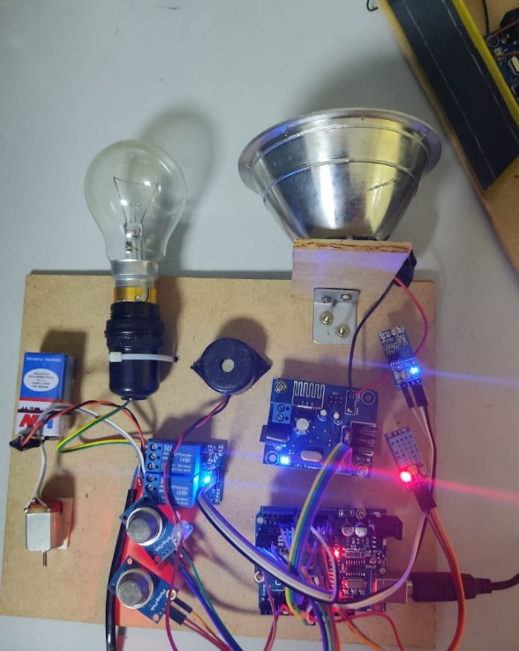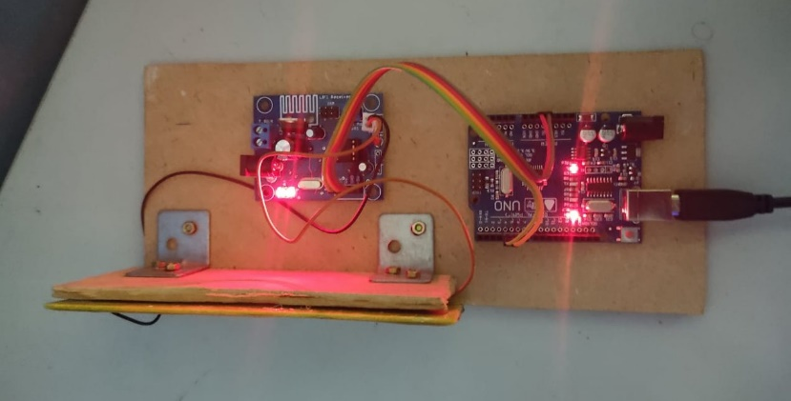

**Figure A.1.1** Transmitter and receiver side

* **HUMIDITY SIMULATION OUTPUT**

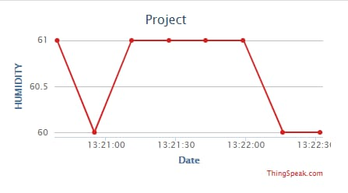

**FIG A.1.2**

* **TEMPERATURE SIMULATION OUTPUT**

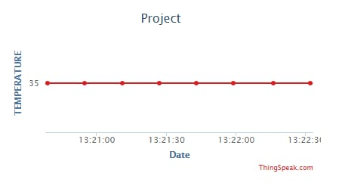

**FIG A.1.3**

* **LDR SIMULATION OUTPUT**

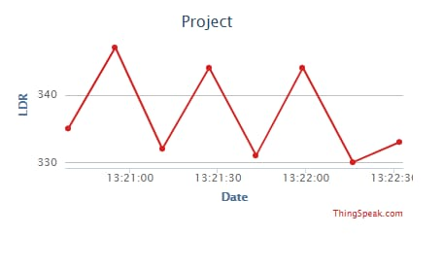

**FIG A.1.4**

* **GAS1 SIMULATION OUTPUT**

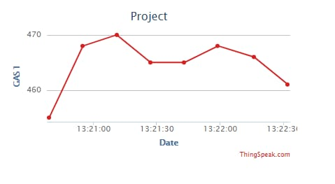

**FIG A.1.5**

* **GAS2 SIMULATION OUTPUT**

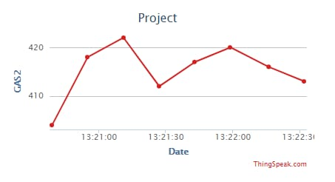

**FIG A.1.6**

|  |  |
| --- | --- |
|  | **PUBLICATION:**  M.S.Vinmathi1 , V.Kavitha2, V.Kushmasri3 , V.Lavanya4 “IOT BASED MONITORING SYSTEM FOR COAL MINING ENVIRONMENT USING LI-FI” ISSN : 2321-9653  VOLUME : 9  ISSUE : May 2021 |

**REFERENCES**

[1].VALDO HENRIQUES AND REZA ALEKIAN,”Mine safety date system using wireless sensor network”, IEEE Trans. Ind. Appl., of publication June 16, 2016

[2] Muzaffer Kanaan and Eda Simsek,”On the use of zigbee technology for coal mine safety”,IEEE Trans Ind.,published in 2016 24th signal processing and communication application conference.

[3] Gang sun; Zhongxin Wang; Jia Zhao; Hao Wang; Huaping Zhou; Kelei sun,”A coal mine safety evaluation method based on concept drifting data stream classification”,2016 12th International conference on National Computation,Fuzzy Systems and Knowledge Discovery.

[4] Miguel Angel Reyes; Thomas Novak,”Injuries surveillance and safety considerations for large-format leadacid batteries used in mining applications”,2014 IEEE Ind. Appl.,date of conference 27 October,20

[5] P. Deshpande and M. S. Madankar, „„Techniques improving throughput of wireless sensor network: A survey,‟‟ in Proc. Int. Conf. Circuit, Power Comput. Technol., Mar. 2015, pp. 1–5

6. Ashish “Coalmine safety monitoring using Wireless sensor Networks”, International Journal of Scientific Engineering and Technology (IJSET) Volume 2, Issue 10, October 2013

7. Wakode “Coalmine safety monitoring and alerting system”, International research journal on Engineering and Technology (IRJET) Volume 4, Issue 3, March 2017

8. Aarthi “Coal Mine safety Monitoring system using ARM 9”, International Journal of Science and Research (IJSR),Volume3,Issue-11,November 2014

9. Dheeraj “IoT in mining for sensing, Monitoring and prediction of underground mines Roof support”, conference on recent information and advancement technology 2018.

10. Cheng “Coal Mine safety Monitoring system based on Zigbee and GPRS”, Applied Mechanics and Material Volume 422, 2013

11. D. Iturralde, C. Azurdia-Meza, N. Krommenacker, I. Soto, Z. Ghas-semlooy, and N. Becerra, “A new location system for an underground mining environment using visible light communications,” in 2014 9th International Symposium on Communication Systems, Networks Digital Sign (CSNDSP), pp. 1165–1169, July 2014.

12 . Abdul: "Wi-Fi-based Mine Safety Application” of International Journal of Scientific and Research Publications. 4, issue 1, Jan 2014.

13. Ghassemlooy, S. Rajbhandari, and I. Papakonstantinou, “Visible lightweight communications Naidu Kolli et al.; International Journal of Advance Research, Ideas and Innovations in Technology

14. http://en.wikipedia.org/wiki/Li-Fi]

15. www.lificonsortium.org

### 